11: Multi-Axis Cobot For Factory Automation

Adrian Guzman, Emily Hamsa, Ethan Woods, Jaishil Shah

**Concept of Operations**

REVISION 0 – Rough Draft/1st Final Draft

12 September 2024

Concept of Operations

for

11: Multi-Axis Cobot For Factory Automation

Team <42>

Approved by:

_____________________________

Project Leader Date

_____________________________

Prof. Kalafatis Date

_____________________________

T/A Date

**Change Record**

| **Rev.** | **Date** | **Originator** | **Approvals** | **Description** |
| --- | --- | --- | --- | --- |
| **0** | 9/12/2024 | All Members | All Members | Draft Release - Revision 0 |
| **1** | 9/26/2024 | All Members | All Members | Changed MCU selection in Section 3.6 |

## 

## Table of Contents

**Table of Contents III**

**List of Tables IV**

Table 1 - Cobot Segment Degrees of Rotation 3

Table 2 - Cost Analysis5

**List of Figures** **IV**

Figure 1 - Multi-Axis Cobot Block Diagram 2

Figure 2 - Cobot Prototype Diagram 3

Figure 3 - Subsystem Flow Chart6

**1. Executive Summary 1**

**2. Introduction 1**

2.1. Background 2

2.2. Overview 2

2.3. Referenced Documents and Standards 4

**3. Operating Concept** **4**

3.1. Scope 4

3.2. Operational Description and Constraints 4

3.3. System Description 5

3.4. Modes of Operations 6

3.5. Users 6

3.6. Support 7

**4. Scenario(s)** **7**

4.1. Transporting and Using Small Objects or Tools 7

4.2. Unpredictable Factory Environment 8

**5. Analysis** **8**

5.1. Summary of Proposed Improvements 8

5.2. Disadvantages and Limitations 9

5.3. Alternatives 9

5.4. Impact 9

## List of Tables

Table 1 - Cobot Segment Degrees of Rotation 3

Table 2 - Cost Analysis5

## List of Figures

Figure 1 - Multi-Axis Cobot Block Diagram 2

Figure 2 - Cobot Prototype Diagram 3

Figure 3 - Subsystem Flow Chart 6

# Executive Summary

In many manufacturing industries, safety and efficiency are critical to ensure a smooth operation within a fabrication facility (fabs) or working environment. Fabs have heavy machinery and moving parts, making it difficult for humans to access certain places. To aid the workforce, collaborative robots (cobots) are deployed within factories allowing human control from safe distances. Cobots range in size, and application, and help streamline processes within manufacturing. This solution will protect human lives and reduce inefficiencies in labor by eliminating the process of entering a hostile or hazardous work environment.

This project aims to develop a multi-axis collaborative robot (cobot) that replaces manual human intervention with remote control, reducing the risk of injury and fatigue while improving efficiency in factory settings. The cobot will assist with light tasks such as lifting small loads (1-2 lbs), transporting items between locations, and providing precise movement control through a wireless app. Key software tools for the design and development include Altium, CCStudio, AutoCAD, and VSCode (with Swift). The cobot's hardware will feature a C2000x MCU and multiple B161x motor drivers to ensure reliable operation.

Versatility is a big focus of the cobot’s design, and thus we are including the ability to lift a small object or lightweight box using the pincher arm. The cobot will be battery-powered with rechargeable batteries, with a voltage supply range of 24-48V. Additionally, a wireless app will be developed for precise control of the cobot’s movements. To maximize its range of motion, the cobot will contain 5 axes of rotation supporting both 180° and 360°. Internally, the cobot will be driven through TI’s best-in-class C2000™ MCUs, power ICs, and motor drivers, ensuring precise motor control.

# Introduction

Factories and commercial industries use cobots to perform tasks that are unsafe and require numerous movements that would be considered strenuous for humans. Thus, the goal of this cobot is to make the production process safer and more efficient. For this project, we are developing a multi-axis cobot that will facilitate the movement of different loads across a factory or commercial setting. The cobot will be wirelessly connected using a mobile device, battery-powered, and support loads of 1-2 lbs. Considering that many warehouses have safety regulations and guidelines to follow, this cobot is designed with many of these in mind. Thus, this project’s main focus is to develop an operational cobot that could be placed in a factory setting to complete tasks safely and in a time-oriented manner.

## Background

Collaborative robots, also known as cobots, are a crucial component in factory settings where safety is at the utmost priority and manual labor is considered too dangerous. By having the cobot function through remote control, we can increase the safety and efficiency of workers in these industrial settings, where small tasks could be performed by these cobots rather than human workers. This project aims to develop a multi-axial cobot that can lift a load of 1-2 lbs through a wireless connection.

## Overview

1. Designing a block diagram and flow chart including the key operating specifications.
2. Develop the motor driver, microprocessor, power supply, and battery management control with safety systems, and respective PCBs for each.
3. Develop a user interface to control the cobot in the form of a wireless app.
4. Develop the physical design of the cobot, including the machine and any 3D-printed parts.

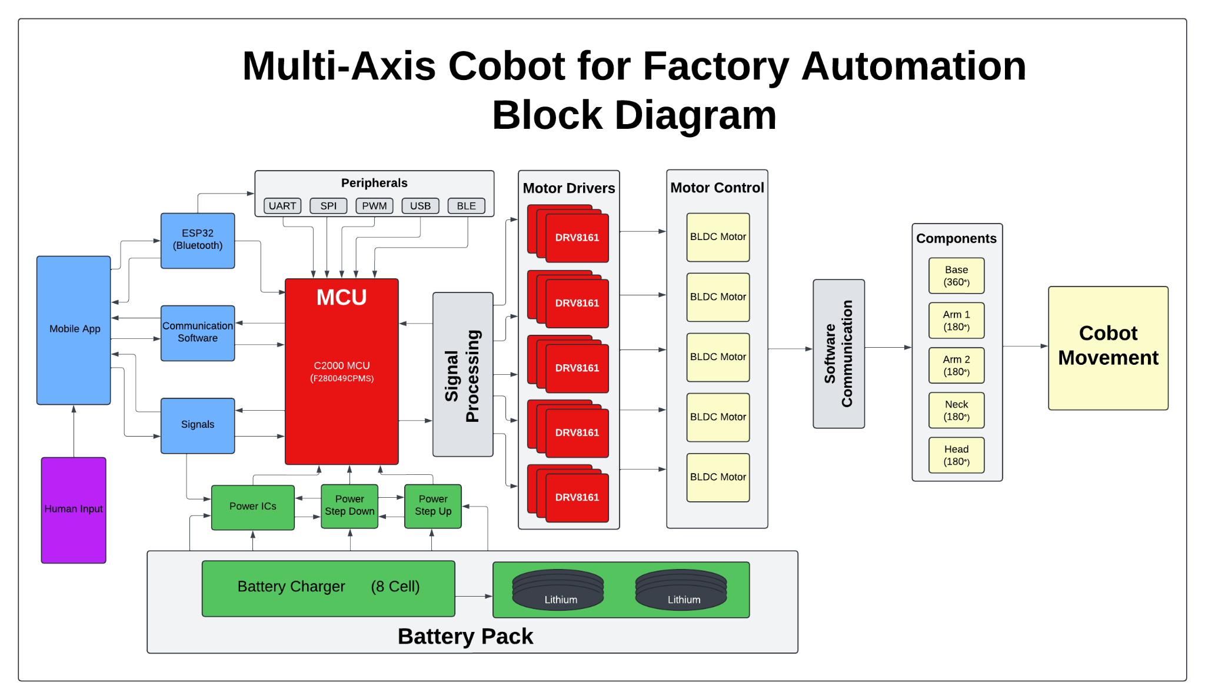

## Figure 1. Multi-Axis Cobot Block Diagram

| **Segment Piece** | **Degree of Rotation** |
| --- | --- |
| Base | 360° |
| Arm 1 | 180° |
| Arm 2 | 180° |
| Neck | 360° or 180° |
| Head | 180° |

## 

## 

## Table 1. Cobot Segment Degrees of Rotation

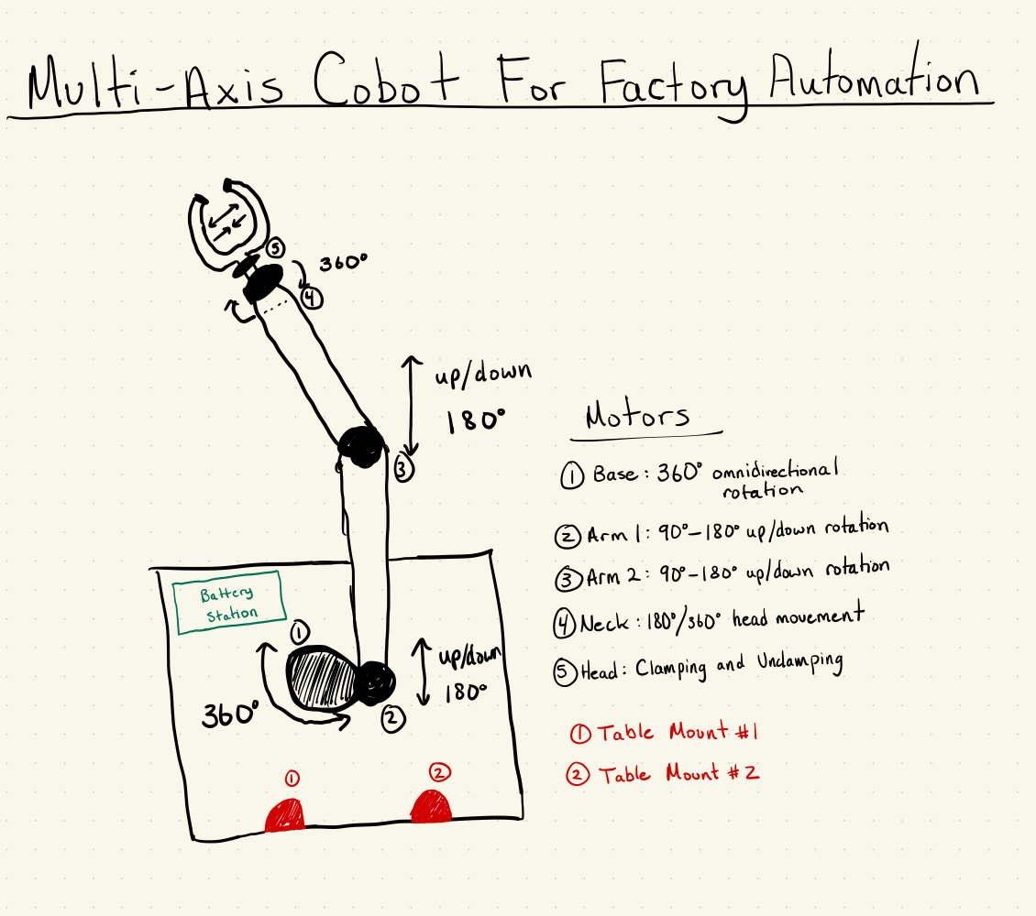

## Figure 2. Cobot Prototype Diagram

## Referenced Documents and Standards

**Project Outline:** [Project Description](https://drive.google.com/file/d/1vJtw75IHhgVgzJuWyFkPAn4qMTbb-3Aw/view)

**MCU Documentation**

#### C2000 MCU Documentation: [F280049CPZS](https://www.ti.com/product/TMS320F280049C/part-details/F280049CPZS)

#### C2000 Evaluation Module: [LAUNCHXL-F280049C - EVM (C2000 Evaluation Module)](https://www.ti.com/tool/LAUNCHXL-F280049C)

**Motor Driver Documentation**

DRV816x Motor Driver Documentation: [DRV816x 100V Half-Bridge Smart Gate Driver](https://www.ti.com/lit/gpn/drv8161)

DRV8161 Evaluation Module: [DRV8161 EVM](https://www.ti.com/tool/DRV8161EVM)

**Wireless Control Documentation**

ESP 32 Documentation**:** [ESP 32 Technical Reference Manual](https://www.espressif.com/sites/default/files/documentation/esp32_technical_reference_manual_en.pdf)

Swift Programming Course: [Swift Programming Fundamentals](https://www.coursera.org/learn/programming-fundamentals-swift)

**Motor Documentation - TBD**

**Battery Documentation - TBD**

**Physical Design Documentation - TBD**

**Standards Documentation - TBD**

# Operating Concept

## Scope

This project involves the design and fabrication of a human-controlled, multi-axis collaborative robot (cobot) for use in a variety of manufacturing and commercial environments. The cobot will assist employees by improving efficiency in both strenuous tasks, such as moving boxes, and precise tasks, like handling small loads and assembling items. Operated remotely and equipped with a pincher-style head, it is designed to enhance productivity in diverse settings, performing repetitive and labor-intensive duties that benefit from human oversight and precision.

## Operational Description and Constraints

The cobot will work wirelessly in commercial industries as well as factory settings performing tasks such as moving boxes and small loads, and the operator will use an app to control the cobot. The claw attachment will be used for precise tasks such as moving small objects and loading boxes, as well as moving small boxes between locations. It will move on multiple axes, ranging from 180 degrees to 360 degrees of rotation at each joint, and will be powered by a rechargeable battery.

One constraint of this project is the weight constraints on the load the cobot can lift. The design is only specified to operate in lifting loads up to 2 pounds. The radius of its reach is another constraint, as it will only be able to reach 2 feet from its base. Design constraints will also need to be accounted for. There is a limited budget of $400, and a limited time frame to complete the design.

This cobot has applications in many industries, including the semiconductor, automotive, medical industries. This cobot could be modified to lift and move wafers in a semiconductor clean room setting. Being able to lift boxes would aid employees in the automotive field when building cars, and would be able to precisely move and place lighter metal parts. In the medical industry, the cobot would be able to use its precision for moving small tools such as tweezers or scalpels, assisting doctors during surgery.

| **Product** | **Quantity** | **Cost** |
| --- | --- | --- |
| EVM Board (MCU) | 2 | $78.00 |
| Microprocessor Unit | 2 | $17.89 |
| Bluetooth Driver | 1 | $19.99 |
| EVM Board (Motor Drivers) | 1 | $229.00 |
| Motor Driver Chip | 5 | $5.66 |
| Anti Static Wrist Strap | 2 | $13.98 |
| Robotic Arm Pincher | 1 | $26.99 |
| **SUM:** |  | **$391.51** |

## Table 2. Cost Analysis (To be updated)

## System Description

The system will be split into four subsystems: power and battery management, MCU and processing design, wireless connectivity and interface development, and motor driving system design. The physical construction of the cobot will be divided amongst team members equally in a 25% share.

The power and battery management system covers the design of the power PCB which will deliver power to the motor drivers, motors, MCU, Bluetooth systems, and other electrical components. On the battery management side, this system will cover the selection of a battery and the design of a battery charger. This system will also account for possible faults and implement safeguards to protect the system.

The MCU and processing subsystem are responsible for the MCU PCB design, ESP32 Bluetooth integration, and communication between the MCU and motor driver. This subsystem will use Altium to design schematics and build physical hardware using the C2000 MCU. Furthermore, the MCU/Processing & Motor Driving subsystems will work closely to align on signal communication between the MCU and motor driver.

The wireless connectivity and interface system consists of a mobile application and a Bluetooth connection that allows communication between the cobot and the device sending in the inputs. The mobile application will be developed using Swift and will be compatible with any iOS device, including iPad and iPhone. It will allow the user to control all movements seamlessly and wirelessly. The Bluetooth driver, an ESP-32, will connect directly to the MCU and allow the C2000 to take the inputs from the mobile device and convert them into outputs performed by the cobot. Since we are using a Bluetooth interface, the multi-device connection is compatible and allows any device to connect.

The motor driving design system will create the motor and motor driver PCB. This system will also create the signals needed to effectively operate the motors, which will be Brushless DC (BLDC) motors. This system will achieve the operation of two motors, a 360° and 180° motor controlled by the 8161x TI Motor Drivers. The motor drivers will read a signal from the C2000 MCU and spin/rotate as needed based on the signal. This will all be driven through the B161EVM before integration.

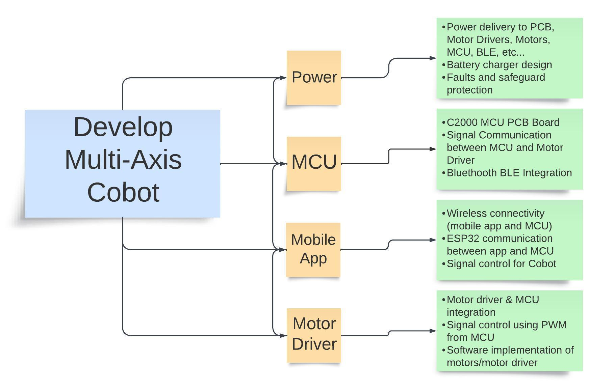

## Figure 3. Subsystem Flow Chart

## Modes of Operations

The cobot operates in three distinct modes. In the first mode, it uses its pincher to handle and pick up smaller objects in areas where employees may be present, though their presence is not required as the cobot is remotely controlled. The second mode involves lifting, moving, and placing down objects or boxes, as well as tasks such as using tools or adding items to boxes. The third mode is the charging state, where the cobot recharges its power.

## Users

The target user for this cobot is a factory employee who performs redundant, strenuous tasks such as moving boxes from one place to another, transferring small objects, working with small tools, and loading boxes. These employees will benefit from using the cobot as they will be able to stay outside of dangerous areas to operate the cobot, removing the need to follow protocols to enter. Users will also be able to operate this cobot in areas amongst other employees to complete tasks like moving small loads and boxes.

Training will be required to use this cobot. Basic UI training will need to be completed to understand the functionality of the app, as well as training on using the Bluetooth features. Safety training will also be required to ensure standards are met for using a cobot in a factory setting. Understanding the cobot’s thresholds, such as weight limits, is another important piece of training that will be needed before the operator can begin using the cobot. If the operator plans to use the cobot in areas with other employees, additional training regarding the safety of operation amongst humans may be required to ensure safety on the factory floor.

## Support

Operators will be given a “crash course” on using the mobile application. In-person training on safety standards and operating conditions will also be provided, which will include weight management, operating radius, axis movement, claw operation, and other operating constraints. Operation in areas with other employees will also require additional training. Training on how to repair any damage to the equipment will be provided, as well.

# Scenario(s)

## Transporting and Using Small Objects or Tools

In this scenario, the cobot will be used in an environment where it will have the ability to operate in freedom alongside other human workers, with the goal of moving a small, lightweight object from one location to another. As the cobot is human operated, the primary objective is to transport the item without damaging or breaking it. The human operator must also be aware of the surroundings within the working environment in the case of external human intervention.

The cobot will be equipped with a set of pinchers or clamps with rubber pads attached to the end. It will be able to handle these objects with precision and full range of motion as it lifts the item up. The items the cobot can handle range from 1-2 pounds, such as light tools, food items, loose parts, and small plastic pieces.

The cobot has a hard time picking up flat items using its clamps, so the items would already be upright and ready to grab by the operator. Once picked up, the operator would be able to freely move the object with 360° of rotation and place it down or use the item at a secondary location, within the range of the cobot. This could be as easy as moving an object from one place to another to placing small objects inside bigger boxes.

From an operational point of view, a human operator will control the robot via remote control, responsible for all aspects of its movement and functionality. This includes tasks such as placing and charging the battery, as well as ensuring precise control during the cobot’s movements. As the cobot is not autonomous, it requires a skilled human operator to handle the objects with the necessary precision and accuracy they need, alongside constant monitoring of the surroundings around the cobot, as to not injure or interfere with other workers.

## Unpredictable Factory Environment

In this scenario, the cobot will be used in an environment where working conditions are dangerous for humans, such as hazardous and high-risk spaces. The cobot is human-operated, allowing for the pickup and placement of small, lightweight objects in areas where humans cannot operate safely.

The cobot will be equipped with pinchers or clamps that have rubber pads attached to the ends, allowing it to handle items with precision and care. These objects, weighing between 1-2 pounds, could include small objects that are potentially hazardous to humans. The cobot would struggle with flat items on a surface, so ideally the items are positioned upright already.

Once the object is picked up, the cobot can be rotated 360°, giving the operator full control to transport the item to another location or use it within the workspace. Tasks may range from moving items from one place to another, placing them in larger containers, or completing small assembly tasks. The human operator is responsible for controlling all aspects of the cobot’s movement via remote control, ensuring precise handling of objects and monitoring the surroundings to avoid accidents or collisions.

The cobot is not autonomous and relies entirely on a skilled human operator who ensures that tasks are performed safely and efficiently. This operator also manages the cobot's battery charging, positioning, and any other maintenance required to keep it operational. The use of the cobot in this environment significantly reduces risks for human workers while maintaining the efficiency needed for object handling tasks in hazardous conditions.

# Analysis

## Summary of Proposed Improvements

The multi-axis collaborative robot (cobot) introduces significant enhancements in safety, efficiency, and cost-effectiveness within warehouse and factory environments. By integrating a wireless user interface, the system minimizes direct human involvement, prioritizing worker safety and reducing potential hazards. The cobot’s ability to operate with five degrees of rotation enables it to handle and move objects weighing up to 2 lbs with high precision and efficiency. This capability streamlines repetitive tasks, reduces manual labor, and enhances overall operational productivity. Additionally, the cobot’s design contributes to cost savings by optimizing task performance and reducing the need for manual intervention in potentially risky environments.

## Disadvantages and Limitations

Some limitations of our design include a carrying capacity of 1-2 lbs and an operational range of 2 feet from the base of the cobot. Additionally, due to the size and shape of our pincher mechanism, objects that are flat with little height off the ground will not be supported by the cobot. Since we are catering to industries which may have limited factory space, the range of motion must be precise in order to prevent damage to warehouse equipment and the cobot. One disadvantage of our design is the power supplied to the cobot. Since we are not connecting this machine to direct power but rather connecting a battery, the usage of the cobot will be limited to the duration of the 8-cell battery and the extra rechargeable batteries. To utilize the machine after a full day of use, the batteries must be recharged and plugged back into the machine.

## Alternatives

Some alternate solutions we proposed include a physical controller and a combined cobot head that incorporates a hook and a pinching mechanism. With the physical controller, the benefit is that it would be easier to use, however, the drawbacks are lengthy enough to conclude that it is an inefficient proposition. With a dedicated controller with physical analog inputs, there would be a level of management of the signal interference that is avoided with the mobile application. Additionally, the mobile application allows many devices to communicate with the cobot, as well as being able to connect to different cobots. The final drawback of the physical controller is that if the device gets damaged, replacing or fixing it would be very costly. With a mobile application, releasing a software patch to fix any bugs lowers cost as well as time to resume functionality. The other alternative would be creating one cobot head with the hook and pincher attached. The issue with this solution is that it is not as professional in design, and does not display the versatility of the cobot in a consumer-friendly manner. Additionally, the hook is capable of damaging delicate parts that a dedicated rubber-headed pincher is capable of safely transporting.

## Impact

The multi-axis collaborative robot (cobot) is designed to enhance operational efficiency and safety within manufacturing and commercial environments. By allowing human operators to control the cobot remotely, it reduces the physical strain and risk associated with repetitive or demanding tasks, such as moving objects and loading items. This shift not only minimizes the risk of worker fatigue and injury but also optimizes task precision and productivity.

Moreover, the cobot contributes to a safer work environment by performing tasks that could otherwise expose employees to hazardous conditions. Its presence in factory and warehouse settings helps maintain a safer operational environment by enabling workers to manage and control the cobot from a distance. This approach supports overall improvements in workplace ergonomics and efficiency, making it a valuable asset for modern manufacturing and commercial operations.